Describe major services (functionality) provided by a hospital's reception.

SummarHospital Management System is a large system including several subsystems or modules providing variety of functions. Hospital Reception subsystem or module supports some of the many job duties of hospital receptionist. Receptionist schedules patient's appointments and admission to the hospital, collects information from patient upon patient's arrival and/or by phone.For the patient that will stay in the hospital ("inpatient") she or he should have a bed allotted in a ward. Receptionists might also receive patient's payments, record them in a database and provide receipts, file insurance claims and medical reports.

## **Aim**

To describe the **major services and functionalities** provided by the **Hospital Reception Subsystem** within a **Hospital Management System**. The reception module ensures smooth patient registration, appointment scheduling, admissions, and payment handling.

## **Procedure (Step-by-Step Process)**

### **Step 1: Identify the Key Functions of the Hospital Reception**

The hospital reception subsystem handles various responsibilities related to patient management and hospital operations.

### **Step 2: Define Major Services Provided by the Reception**

#### **1. Patient Registration**

* Collects patient details (name, age, gender, contact, medical history).
* Generates unique patient ID.
* Updates patient records for returning patients.

#### **2. Appointment Scheduling**

* Schedules appointments with doctors based on availability.
* Modifies or cancels appointments upon request.
* Sends notifications or reminders to patients.

#### **3. Patient Admission (Inpatient Management)**

* Allocates beds for inpatients.
* Assigns wards based on availability and patient needs.
* Updates hospital database with admission details.

#### **4. Payment Processing & Billing**

* Receives consultation and treatment fees.
* Issues receipts for payments.
* Processes insurance claims and medical reports.

#### **5. Data Management & Reporting**

* Maintains and updates patient records.
* Generates reports for hospital administration.
* Assists with patient inquiries and general hospital information.

### **Step 3: Execution & Workflow**

1. **Patient Arrives or Calls** → Receptionist collects information.
2. **If an Appointment is Needed** → Schedule or modify it in the system.
3. **If the Patient Needs Admission** → Assign a bed and update records.
4. **Process Payment** → Generate receipts and update database.
5. **File Insurance & Reports** → Process claims and provide documentation.

Activity DIagram

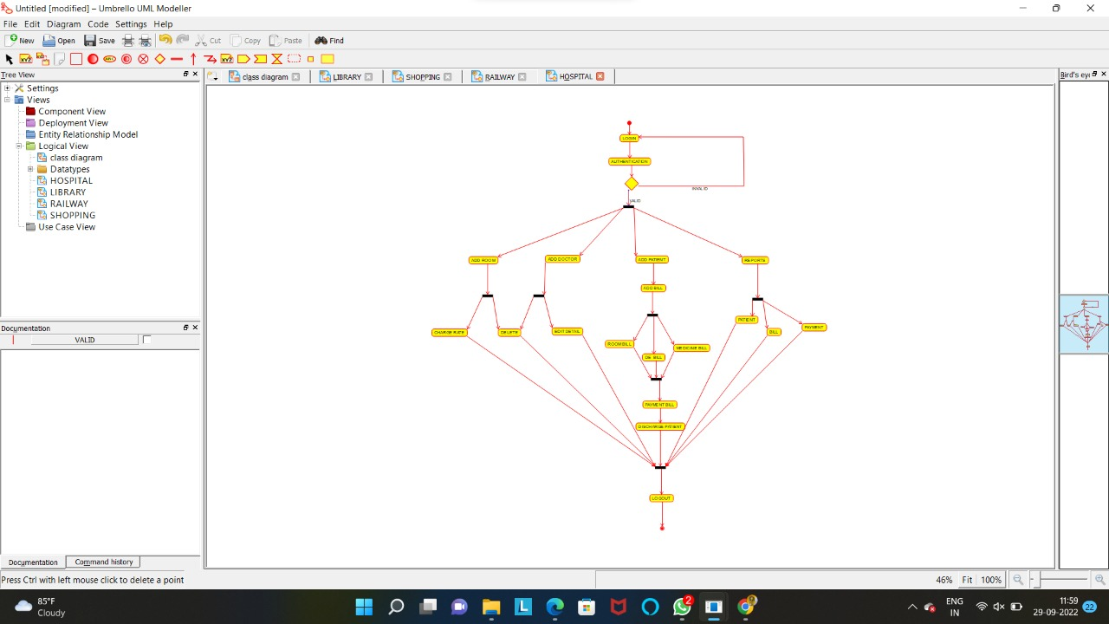

## **Result**

The **Hospital Reception Subsystem** ensures efficient **patient registration, scheduling, admissions, and billing**, leading to **better hospital management**. It streamlines operations, minimizes errors, and enhances **patient experience and record-keeping**.